CSC 3320 System Level Programming

Lab Assignment 6 Out-of-Lab

Dang Truong

ID# 002420309

PART A:

1. .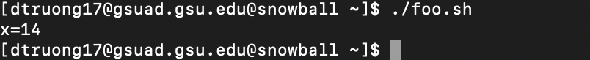
2. we assigned 0 to x and 1 to i, the while condition check if i is less than or equal to 3 and the condition will continue to loop until it becomes false and exits, after the loop, it will go to next operation which is s =i\*i, then x = x+s, while loop will continue to loop until the condition becomes false, when it became false, the command echo x = $x will display the value of x.

PART B:

1. 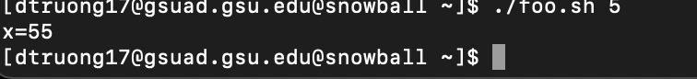

PART C:

1. Text

   Description automatically generated

PART D:

1. Text

   Description automatically generated

public class foo {

public static void main(String args[]) {

int x = 0, i = 1, s;

while (i <= 3) {

s = i \* i;

x = s + x;

i++;

}

System.out.println("x=" + x);

}

}

PART E:

1. Text

   Description automatically generated
2. hello is the new file created after the command cc -o hello hello.c
3. 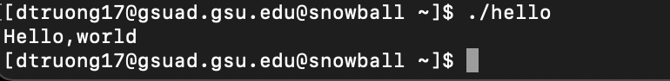
4. Graphical user interface, text, website

   Description automatically generated

* #include<stdio.h>

int main(void)  
{  
printf("My name is Dang Truong\n");  
return 0;